**The Nickelsburgs And The Holocaust – Three Essays**

Jerry Nickelsburg

Winter 2017

These Essays Are In Remembrance of My Cousins

Hilde Elisabeth Nickelsburg

And

Rosalie Nickelsburg

And

Lilli Baer

I never knew them

May the meaning of their existence and their murder be forever in our minds

And to My Mother

Dana Joan Langfeld Nickelsburg

Angels appear mysteriously and at unexpected times

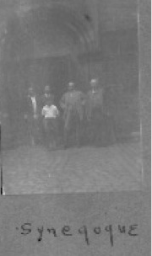

Prologue to The Essays

The essays that follow are part of the story of the Nickelsburg’s and the Holocaust, the part that I know. I have written them so that future generations might have some sense of how we fit into all of this and more importantly that we do. I am 67 years old now. I have been researching this almost all of my life. I tried to write the story of my grandfather, Melvil Nickelsburg, about 20 years ago and found that as hard as I tried, I could not write it. That fact was a bit of a puzzle to me as I write all the time and rarely if ever have writer’s block.

It finally occurred to me that the reason was that I was so personally entangled in the story that if I did not work to set out my own journey as it related to the Holocaust first, I could never see clearly how to tell the more important story of my grandfather. As well, I am a very private person and writing about myself was quite tasking. So this is both a history and a very personal journey. I finished it in 2015, at least I thought. But I still could not seem to muster the energy to really put it to bed. Now in 2017 in the early days of what seems to me a fast moving authoritarian regime, it is incumbent upon me to do that.

What follows are three essays. The first is about me and about some of the impact of the Holocaust on our branch of the Nickelsburgs. The second essay is the story of my grandfather Melvil Nickelsburg. He is a giant and I am so proud to be his grandson. But it is not a biography, just a snapshot of an important event, The Holocaust, set in the context of a very brief family chronology. As I worked my way through it over the years I found we had another connection to the Holocaust, one that could not and should not ever be ignored and this forms the basis for the third piece. The third is not really an essay, it is just fragments about family we lost in the Holocaust who but for the remembrance would be lost in time. In the process I have found that a cousin, thought lost in the Holocaust, survived and his eight grandchildren live in the U.S.

Jerry Nickelsburg

Winter 2017

*Essay No. 1:* *I’m What? You’ve Got To Be Kidding*

The first of these three essays is about me. It may help explain why the second, about my Grandfather Melvil, came to be so important to me to tell.

It begins when I was in third grade at Walter Reed Elementary School in Arlington Virginia. This would have been in 1956 when I was 7. We lived in the segregated South. Most of the people I knew were both white and Protestant; though there were some Catholics and Mormons strewn about.

One brisk fall day we were playing football on the lawn in front of the school. As I recall there were 14 to 16 of us. We were having a good time and my team was winning. I was playing wide receiver on the right side of the line along with a boy I knew, Bob Arberg. Bob was a friend, though we did not often hang out together. He remained a friend even after he dated the cute redhead I had a crush on.

On one particular play, the ball was hiked to the quarterback and Bob and I ran downfield. The ball was thrown to the left side and dropped. So we walked back to the line of scrimmage. We were only 3rd and 4th graders and so we did not realize there was any benefit to a huddle. As Bob and I got back, he shouted to the quarterback something to the effect of “Hey, you (I forget the quarterback’s name) stop being a Jew with the ball and throw it to me sometime.” I did not think anything of it, but then something bizarre happened. He looked over at me and said, “Oh, I’m sorry Jerry, I did not mean that.” I started to ask him what did he mean? And why did he apologize to me? But the next play started, the ball was thrown to Bob, and we scored a touchdown. So, I let it drop.

The game broke up when it got dark and I headed home. After a scrumptious gourmet dinner prepared by my Mom (it was probably liver and onions or something equally gross) I went upstairs. I remember that my sister, Babette, was sitting on her bed. I went into her room and told her about the comment and said: “why did he say that, I’m not a Jew?” And she said: “actually, yes, you are.” She was 9 so she used words like “actually.”

My brother, Mike, is much older than me and we shared a bedroom. I’m sure this horrid kid he had to share a room with was not a picnic. Yet he was always a very good brother and roomie and though I did not appreciate it at the time, as I look back I surely do and I love him for it. Still we did not talk about such things as the “Jew” stuff.

This was a pivotal moment in my life. I was hit with a Tsunami of dissonance. I didn’t really know what all of this meant. I had heard of Jews. They crossed the Red Sea and fled the Egyptians and such, but those were just stories, mythologies which were about as true to me as Treasure Island. I didn’t really know any Jews, except now I guessed I did because I had a sister, brother, mother and father. But I knew for sure this revelation was more than just an explanation of an off-hand, possibly derisive, remark on the football field. If this thing, this being a Jew, was important enough for Bob to apologize to me, someone who had no idea he was one, why had my parents never told me? Was it a secret? Apparently it was! Something really important about me was so ominous that it had to be a secret? Or was this just some mistake? No, I didn’t think it was a mistake – not with my parents. I also learned in that moment that my sister could be trusted because she did not keep this secret that my parents had so carefully hid from me.

Wow, this was quite a day in the life of a 7 year old. I did not know what to do with my new found knowledge, and so for a long time I did nothing. I just listened and tried to learn and understand. In an off moment I asked my Granny while sitting on the couch at our 18th Street house, “ Is it true that you are a Jew?” She was a bit taken aback (this relates to the next essay on Melvil) and then said, “well yes but I don’t go to Synagogue and such.” Uh oh, a new word to figure out.

I poked around this for the longest time. There was no opportunity to act or do otherwise, even if I had wanted to. Somehow I knew I had to continue to play the game. I didn’t really know why, I just knew that if my parents thought it so important to keep this secret from me, there must be something to it. I just went on being a bratty kid. And I was a very bratty kid! My children can’t imagine how troubled I was. As I look back, I think I could well have been the poster child for “at risk children.” But I digress, this Jew thing, it was always in the back of my mind.

I viewed St. Michael’s Episcopal Church, the church my mother took us to, a bit differently though. Once I asked my Dad to let me stop going to church. He said no. My response was, well we aren’t really Christian and anyway you don’t go so why should I? I have to admit, my motivation was to sleep in on Sundays and not be required to wear a white shirt and tie to a boring service. It really had nothing to do with being Christian or not. Dad became furious, a normal occurrence in our relationship. But it was more than a little different than usual. I still can’t pick out how it was different, but I knew from the start this was going to be a different kind of conversation. He ended the conversation with (yelling here) “your mother wants you to go so you will go!” and he then sent me packing from his office. So I went. The only good thing about church was the sport of watching my brother Mike work as an acolyte. On hot summer days, he would have to stand over the flowers at the side of the altar and now and again he would faint. It was a blood sport, but quite a good one.

I was sent to Sunday school once. This was an option with the alternative being to stay in the main church and listen to Father Dave give a boring sermon that went something like “John 1:xx said this, so you should be good people, love your neighbor, and give money to our mission in the Belgian Congo.” During that first year at Sunday School the teacher told us about the Jews. Ah ha, now we are getting somewhere! I was really expecting to learn some good stuff about myself at the next class, but all I learned was that the Jews had their chance and blew it, so they would go to Hell and the Christians (presumably those of us in this room in Virginia) now had our chance. So kiddies, don’t blow it! I remember sitting on the floor, upstairs in the building attached to the Sanctuary looking at this woman thinking, “how can she possibly know this. She is clearly making this stuff up, and anyway I am not going to sit here and listen to this anymore.” That was the last time I ever went to Sunday School.

I have been a voracious reader for as long as I can remember. When I was in 5th grade I asked my Granny to buy the 20 volumes of The World Book Encyclopedia. She and my father fought about this. He told her “ he is only a 5th grader, this is a waste of money.” But she did it anyway. About a year later I heard him say to Granny something like, “I guess you were right, he is going to read the whole damn thing.” I would go to the library and check out an entire shelf of books to read during the week. It took a while to convince the librarian that I was actually going to read all of those books before library day the next week. My mother used to point this out to teachers who would say that I had no motivation to learn and that is why my grades were not A’s. In my family there were two grades, A and FAILURE. Since I was a B+ student, I was obviously the latter.

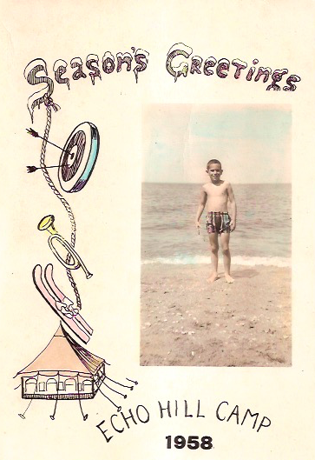

The bratty kid at age 9 I have been telling you about

So one day, perhaps in the 6th grade (so I would be 10), I picked up a book by Leon Uris entitled *Exodus*. I read the back cover. It was a historical novel about the founding of Israel. I liked historical novels and this looked interesting. I really liked the book. It was completely stylized and obviously not very realistic. But I could fantasize about being Dov Landau or Ari Ben Canaan and the sweep of history appealed to me. But there was something else. Apparently something happened with the Jews in Nazi Germany. Clearly Uris did not have it close to right, he had to be making stuff up, but behind his story telling something was unsettling.

Now, I knew the Nazi’s were bad. Everyone knew that. But remember this was only 14 years after the end of World War II, so how bad was not something that filtered down to us. In fact it wasn’t that clear that they were any different from the Japanese. Just bad people who wanted to conquer the world.

The next book on the shelf was Uris’ other novel at the time *Mila 18*. This is a story of the Warsaw Ghetto. I’m not sure I stopped reading once I started. I remember staying up all night reading under the covers by flashlight. Of course it was a glorified story and I knew that. But there were more details about the Holocaust. I was totally stunned. Uris could not have such a vivid an imagination to make all of this up and still get published. The World Book was not much help. It seemed to confirm that Uris was not entirely dealing in fantasy, but it did not satisfy me. It would be years before that would happen. While my reading was still very diverse, I sought out everything I could find about the Holocaust, about Treblinka, Dachau, Sobibor, and Auschwitz. This defining event of modern Jewry was sinking in for the first time. And I began to understand why we were hiding.

I had many long talks with my Mother about this. My father would not even broach the subject with me. I forget exactly what he said, but it was very, very clear I would be treading on thin ice if I were to ever raise the subject again. But my mother was more than willing to talk. We used to do this in the car while we were waiting for something or other or driving somewhere. We used to talk about how, since we didn’t look Jewish, whatever that meant, people would not know by looking at us. And she opined that made us safer. We talked about how Jews were gassed in Europe and no one did anything about it. We talked about how American Jews did not understand that this could happen, and that even if they did, they were afraid the same would happen to them if they spoke up. And we talked about how her family was Sephardic and not really subject to all this…a bit disingenuous given the reason they left Portugal in the first place.

I came to believe that she did not adopt Christianity because she had a revelation on the road to Damascus. I asked her more than once why she changed religions and her answer was always vague and related to how she felt welcome there and she wanted a community she could relate to. I genuinely think that once she adopted Christianity it became heartfelt. It may not have been a thunderbolt from Heaven, but it was genuine. She was not a hypocrite.

Interestingly, whenever we would be in a shopping center or other public place where people would put out information/recruitment tables and we would pass near a table of “Jews for Jesus,” a popular group in those days, a change would come over her. I didn’t really get it, but when she spotted a “Jews for Jesus” table she would break off in mid sentence and make a bee-line to it. (Bees don’t actually go in straight lines but she did.) She would go over and say, “I’m one of you,” and then engage these 20 something converts in long conversation.

In graduate school I stopped playing the game. I came to the conclusion that while I was not religious, the most sensible view of the world to me was existentialism, I was also not being honest with myself. And so I decided that I would not for a minute, not for anyone, deny who I was in order to continue the game. It was time to stop hiding.

From about that time on my relationship with my Mother became strained. After some point, I’m not sure when, she no longer had anything positive to say. And she would avoid me. I made it a point to call each week and to travel to San Francisco to see her, but while she would travel back East to see my siblings, there was always a reason not to come to L.A.

I honestly could not figure this out and it pained me quite a bit. But now I think I know, and I wish she were alive so I could talk with her. For us children, being raised in an affluent suburb of Washington DC in the late 50’s and early 60’s her mindset seemed hard to believe. In the America of 2015 it would be even harder to understand. In 2017, it is perhaps easier to understand. Which is why, I think, it took me a very long time to put it together.

She made an enormous and very painful sacrifice to save her children. In 1949, the year of my birth, with the crematoria of Nazi Germany barely cool and the survivors threatened on all sides in Israel, this was not the hallucination of a crazy woman. It was very rational. Later I came to know a surprising number of people around my age whose mother or father did exactly the same thing. It was actually not uncommon. And so the issue was, quite simply that in spite of all her efforts and sacrifice, when it came to me, in her mind she failed. I was the baby she could not save. I was the one who would not stand down when the Gestapo came.

Now I could be mistaken. It may be that she never got passed me being a hellion as a child. It may be the onset of senility (mine), or it could have been just random. But I don’t think any of those explanations comport with the facts. The hours and hours that we talked about being Jewish, and that it was not just a religion but a people, and that the Nazis would gas you anyway, and importantly, the fact that she never gave me any reason to think of her as anything but my Jewish mother is too much evidence for me to ignore. Catching the car on fire (burned it right up), or sneaking out to go drinking at the Journey Inn in Washington (so many times) might have had staying power, but ought not to have become more important rather than less important to her over time.

But this story is not over yet. In my many attempts to write the next essay about my Grandfather, I found I had to work out this part first before I could properly set the next. During the time I was trying to figure out why we were hiding, I was also trying to figure out who my Grandfather was. Some of the questions I asked my Father, Mother and Granny touched on both, and the more I learned, the more I needed to learn. When you read the next essay, you will see the some or perhaps much of my parents’ motivations that I have written about here developing. As well, you will see why the story of Melvil was almost lost in time. I hope you will continue with the Second Essay, because if you are related to me, I think you need to know who else you are related to.

*Essay No. 2 The Story of Melvil*

*My Grandfather and His Great White Whale*

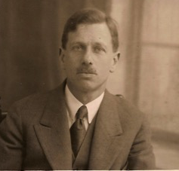

*I. Introduction*

This is a story about my grandfather Melvil S. Nickelsburg. If you are reading this, then perhaps you also have the good fortune to be connected in one way or another to Melvil. It is a story that nearly disappeared with my grandmother Janet (Granny) and my father Stephen. But even that is part of the story. He was named after Herman Melville, hence my essay title.

I don’t know how or why I became interested in Melvil, but all of my life I have wanted to know more about him. Perhaps it was because when Granny would visit our family in Virginia, she and my Dad would comment on how I looked like Mel. They seemed to never agree about anything when it came to me. So, the two of them having the same opinion was noteworthy by itself. But, this went beyond just agreeing on similar facial features, it was as if the comment, really a complement, was a connection through me to something else.

I would ask my Dad about Melvil and would always get the same very generic response. He would tell me that Melvil was a truly nice person, that he was not very interested in business, and that he gave away the family fortune. But he never said this in a bad way. In fact, it was clear that my Dad, who was not wont to be emotionally close to anyone, had an extremely warm spot in his heart for his dad, Melvil.

When I would ask further about Melvil, neither Dad nor Granny would volunteer much more. They chose their words carefully and only little pieces here and snippets there would come out. Over the years, a picture began to emerge. In their waning years they were less careful with what they said. The key to the story came one day when Granny was 89 years old and beginning to fail in health. She told me part of the story, and the rest began to fall into place. I feel very fortunate that she did that or Melvil’s secret would have gone with her. When she finished, she was embarrassed and said that she wished she had not said anything, but to our benefit, too late.

Many people have contributed to me being able to pull this story together but especially my brother Mike and sister Babette who gave me their insights and knowledge, my cousins Jonathan Parker and John Rothman, and my friend George Nickelsburg, professor emeritus of the University of Iowa (perhaps related and perhaps not) who has done remarkable genealogical research on the Nickelsburg family and who has always kept us in mind during his travels and research. I am going to set this story in a brief historical sketch of our family to give it some context. Let’s digress for just a moment with:

*II. Our German Origins*

To begin with we should take a look at how all of the people in this story relate to each other. Once upon a time in the 18th Century there was a man by the name of Samuel. He apparently came from the town of Nikolsburg in Moravia. Interestingly I have traveled all over Germany and no one recognizes our name as German, at least not from the part of Germany they are from. When I was in Czech Republic, more than a few people said, “oh! your family is from here.” The same happened to my daughter Monica 43 years later. So perhaps this should be entitled our not so German origins.

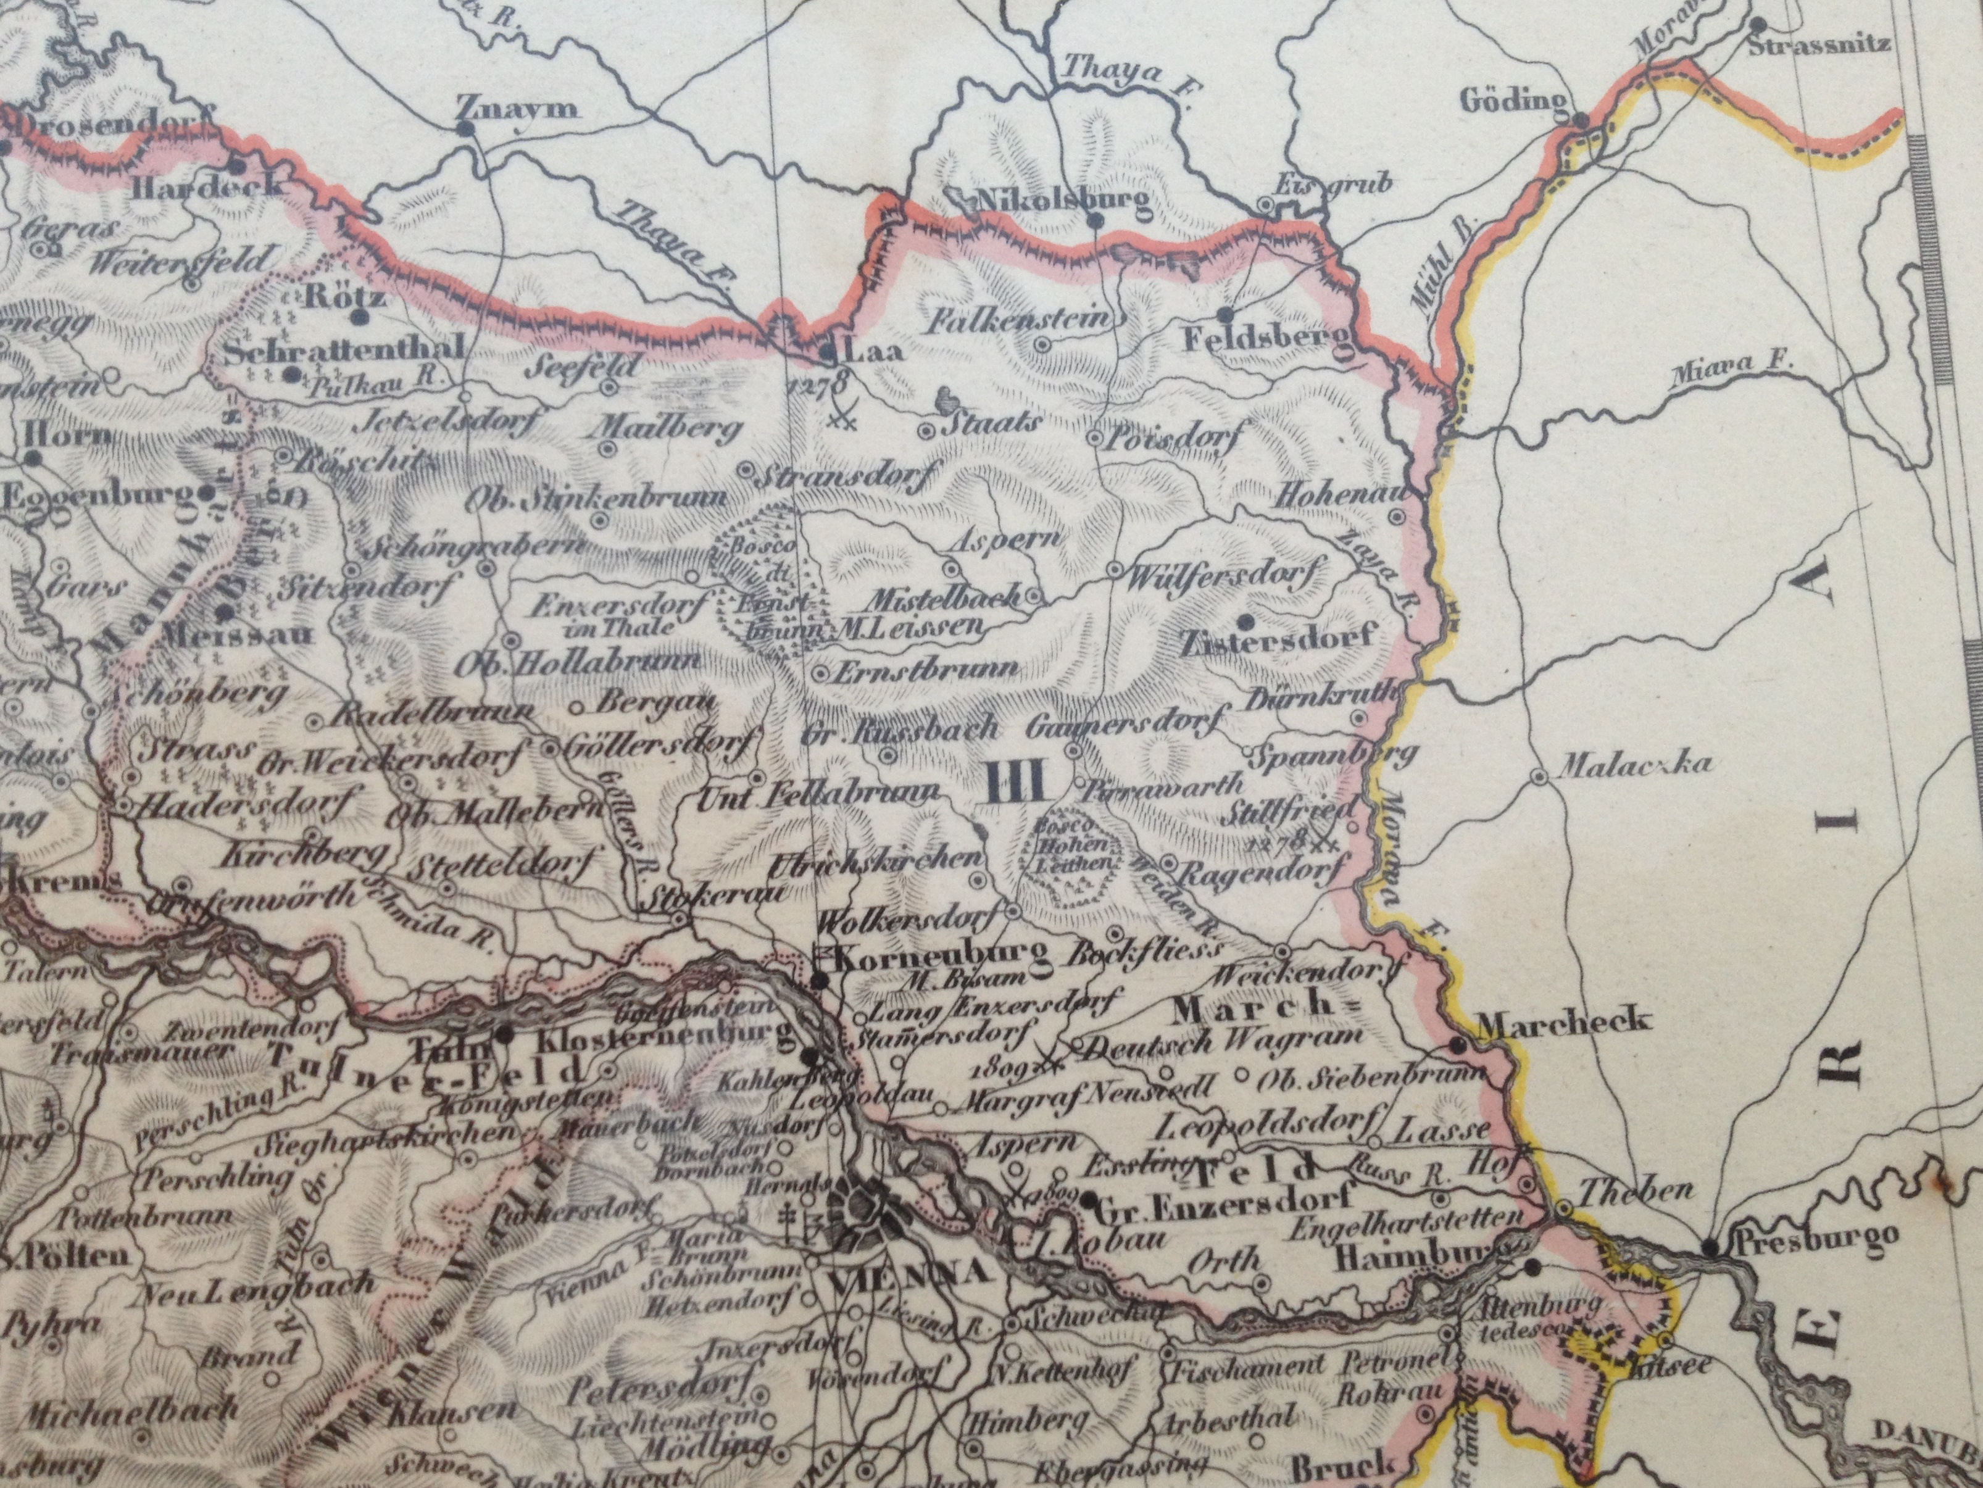

Nikolsburg just across the Austrian Border in Moravia, map courtesy of Mike Nickelsburg. The town is now called Mikulov

The Jewish population in Nikolsburg can be traced back to the 14th Century. As an important outpost of the Austrian Empire it became a center of trade and learning. Where the Nickelsburg’s were before they were in Nikolsburg is impossible to say. We do know through the benefit of genetic markers, that the male line of the family followed an uncommon route from the Middle East to Europe. Most Europeans including Ashkenazi trace their descendants back through the steppes of Central Asia and from there back to Africa. Ours come from Israel through Greece and Italy. (We are not quite as German or Moravian as we thought).

Germany had been the center of a rich Jewish life, but in the 14th Century the Jews of Germany were driven from their towns by the two-pronged attack of poverty and Crusader led pogroms. Cities and villages outside of Germany were enriched by the arrival of German / Yiddish speaking Jewish migrants. Nikolsburg, being Moravian and a colonial dominion in the Austrian Empire was an important outpost on the road from Vienna to the northern Slavic Domains. Being on the edge of the German-speaking portion of the Austrian Empire and a central trading village made it an attractive place for the Jewish refugees from Germany. It is not known if Samuel’s family was part of this refugee population or arrived from elsewhere during this time.

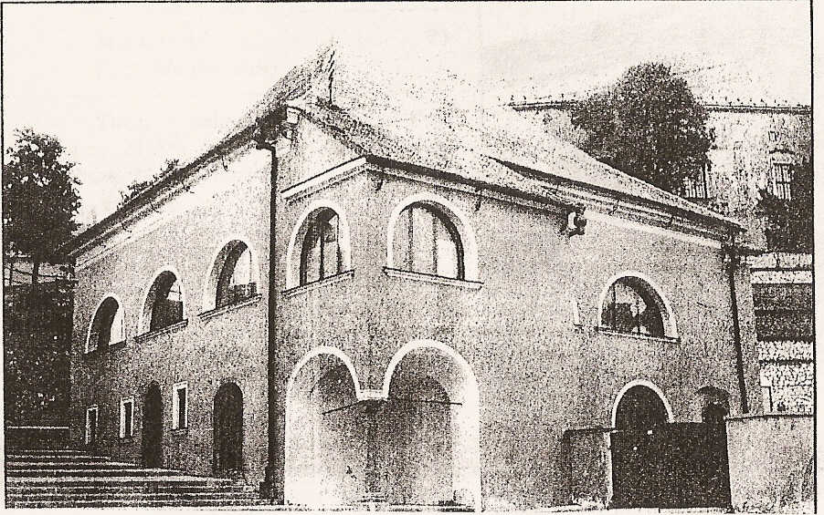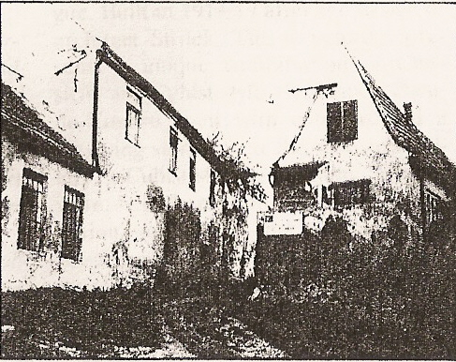

**Two views of Nikolsburg, Moravia, Czech Republic from *Jewish Sights of Bohemia and Moravia*, by Jiri Fiedler, published by Sefer (Prague)**

By the 18th Century Jews were finding new opportunities in Germany and although there were restrictions on their lives, including living in the Jewish Ghettos, Eastern European Jews began migrating back to the West. In 1771 at the age of fifty-five Samuel appears in Worms and applies for a residency permit. As was typical in the 18th Century, Jews took surnames based on where they were from or based on their trade. It appears that Samuel took the name of Nickelsburg as he settled into his new life in Worms.

Worms (now a part of Rhineland-Pfalz state in Germany) was an important part of the loosely organized states of Germany. It had been designated as a Reichsstad, a city-state, and gained prominence during the Middle Ages as the seat of the Imperial Council of German States (the famous Diet of Worms). The large and important Jewish community of Worms was decimated in the late 13th and early 14th Centuries. At the time Samuel arrived it was beginning to come back into its own.

Samuel married Esther Deuches and in 1773 had a son named Salomon. In 1808 Salomon legitimized the use of the name Nickelsburg as required by Napoleonic law. Solomon was a merchant as were many of the Jews of the German States during the time of the Holy Roman Empire. The lives of the Jews of Worms were relatively comfortable for the times. Although they were restricted in their activities and in property ownership, 19th Century Jewish life in Germany flourished.

In 1803 Salomon, age 30, Married Reitzge Mayer. Absent video games and a local movie theater they had (at least) seven children. Two of these children are central to the story. One was named Samuel (whose was born in December 1803…10 months after his parents wedding) and the other Markus (or Meir). Samuel stayed in Worms and he and his progeny prospered.

Markus had twelve children including Siegfried (born 1841, 1846 or 1849) Melvil’s father. Markus was a bit more restless and had his eye on the New World. Sometime in the 1840’s – probably 1849 Markus and three other male members of the family left Worms for California. This may explain the 1849 “birthdate.” It appears that gold fever had hit Germany. There are unconfirmed family stories of a young Siegfried riding on the bags of feed in a Conestoga Wagon across the American Prairie. If he were born in 1846 this would make sense, though traveling with a 3 year old must have been a challenge. Were he born in 1841 he would have been 9 years old and though he might have ridden, he would probably have walked next to the wagon with everyone else most of the way. These were the stories that Siegfried told my Dad when he was growing up. Markus left California as some point and returned to Germany. I’m not sure when this was, but he is buried in the Jewish Cemetery in Worms.

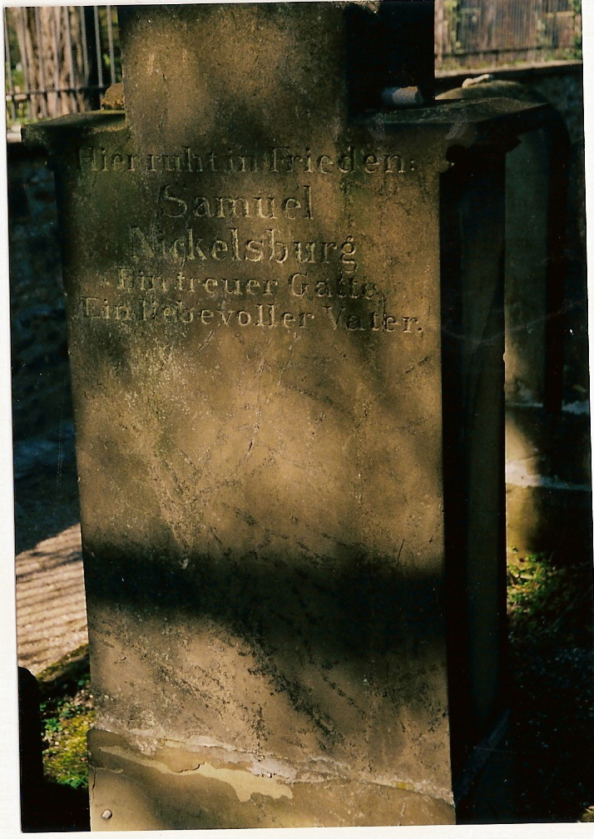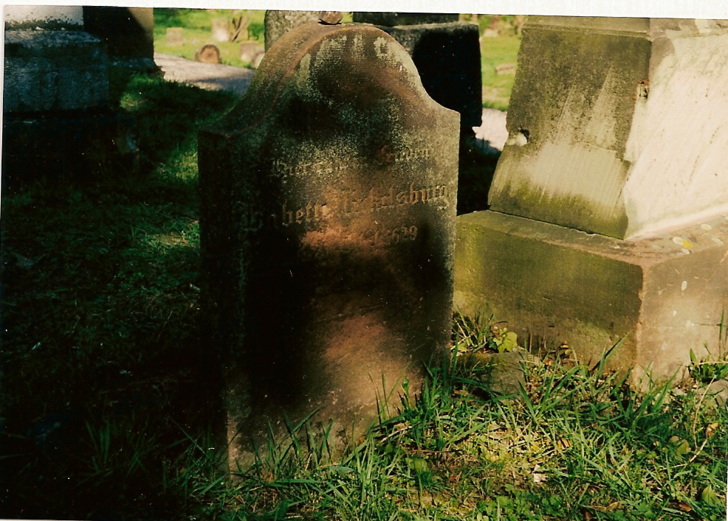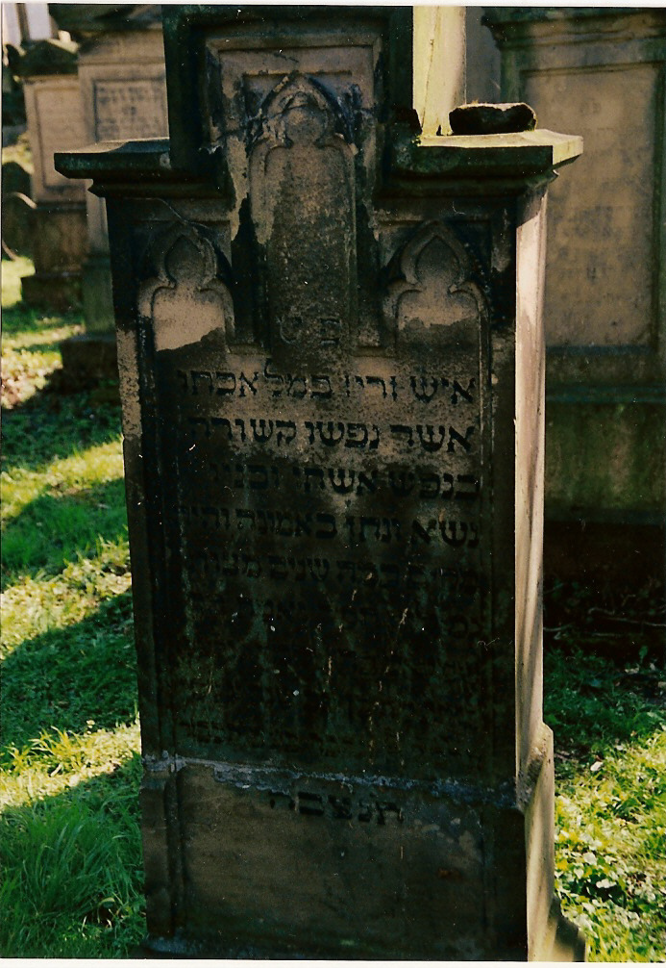

Photos: Samuels Headstone, Babette’s Headstone (Markus 2nd Wife), Hebrew Headstone, Old Jewish Cemetary, Worms Germany. Photos Courtesy of George Nickelsburg

*III. California*

The Nickelsburgs arrived in San Francisco in 1850. Whether Marcus actually went looking for gold is not known. When Siegfried grew up he married the daughter of another German Jewish immigrant, Palmyre Cahn. He and Palmyre’s family established a shoe manufacturing company called Cahn-Nickelsburg Boots, Inc. As all of our family in San Francisco discovered, you cannot lose in the gold fields if you are selling boots, jeans, coffee or rice to the gold miners. Siegfried did very well and lived a life of wealth and privilege in the new West.

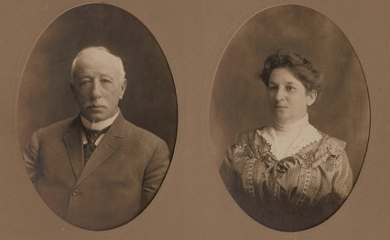

Siegfried Nickelsburg and Palmyre Cahn Nickelsburg

Samuel stayed in Worms and married in 1833. He and his wife Elisabethe had three children, Isadore, Siegmund, and August. Siegmund married in 1868 and had five children including a son, Leopold, who was born in the same year his parents were married, and a daughter Rosalie. We tend not to wait long to beget in this family. Leopold would be Melvil’s 2nd cousin and Siegfried’s 1st cousin once removed. In 1899 Leopold married Rosa and in 1901 they had one child, Hilde Elisabeth Nickelsburg.

Siegfried and Palmyre begat our central character Melvil. They were well off, though not at the level of the Hellman, Brandenstein or Strauss families. Nevertheless, life for Melvil and in general for the Jewish community in the late 19th and early 20th century in San Francisco must have been quite good.

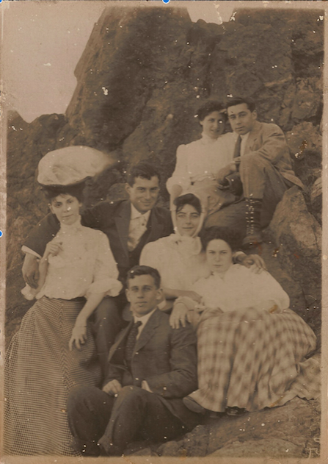

Melvil (lower center) and Friends relaxing at the shore in California

*How They Relate To One Another*

This is based partly on research by George Nickelsburg and partly on family records. There are many siblings and branches that are not shown as they would just confuse how the main players in this story relate. The dates may not be accurate. More information can be found in the family archives.

Samuel Nickelsburg m. Ester Duesches (Deiges)

1736-1799

Saloman Nickelsburg m. Reitzge (Rosine) Meyer

1773-1839 1803 1770-1831 _______________________________________

| |

Samuel Nickelsburg m. Elisabethe Scheftel Meir/Markus m Hawah/Eva Sommer

1803-1885 1809-1882

| |

Siegmund Bernhard Nickelsburg m Mina Wetterhahn |

| |

_________________________________________ |

| | |

Leopold Nickelsburg m. Rosa Viktor Rosalie Nickelsburg m Max Baer |

1868-1938 1869-1942 |

| | |

| _______________ |

| | | |

Hilde Elisabeth Nickelsburg m Fritz Freund Ernst Baer Lilli Baer |

1901-194? |

_______________________________________|

|

Siegfried Nickelsburg m. Palmyre Cahn

1841- |

|

Melvil Nickelsburg m Janet Jacobi

|

Stephen Nickelsburg m. Dana Joan Langfeld

1918-1971

Melvil grew up in San Francisco and on a hike on Mt. Tam he met my grandmother, Janet Jacobi. Reportedly it was love at first sight and they ultimately married. They had three children, Stephen (my Dad), Edith and Ruth. My Dad was born in 1918. Melvil ultimately took over Cahn Nickelsburg Boot and Shoes and ran it until he retired.

It is not clear what happened to the company. Someone with more family history might know. However Melvil retired with sufficient resources to not have to work again. In part it was due to the trust fund set up by J.J. Jacobi for his daughters, but my impression is that when he retired he had a reasonable grub stake of his own. However, rumor has it that J.J. did not trust that Melvil would manage his resources very well. In a memoir of Granny’s she said that Melvil was a bit sensitive about this so she never talked to him about money.

The reason for Melvil’s early retirement (he was in his 40s) was either that his business failed or that he had developed MS, or both. Some of Janet’s memoirs suggest that this was a very difficult time financially for him. His condition worsened shortly thereafter and he was no longer able to get around without help. Fortunately, theNickelsburgs were wealthy and could afford help. It was at this time that they modified a house on 22nd Street and the Presidio in San Francisco to be wheel chair accessible.

After consulting all of the best doctors in San Francisco, Melvil and Janet concluded that these frontier doctors had no ideas for them. What do you do if you have considerable means and a condition for which local doctors have no answer in the mid 1920’s? There was only one answer. You head for Germany where the world’s best medicine was being practiced.

So the whole family packed up and headed out to Germany in 1927. When they arrived they first went to Worms where Melvil’s second cousin Leopold lived with his daughter Hilde Elisabeth. My father was 9 at the time. Melvil and Janet left their children behind in Leopold’s house while they traveled Germany and Austria trying to find a doctor who could cure Melvil’s now diagnosed MS. When they returned to Worms it was with the knowledge that Melvil was out of luck.

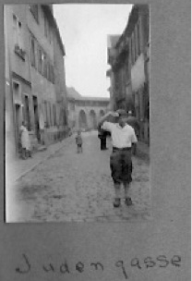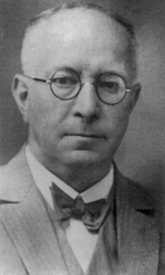

My Dad (Stephen Nickelsburg) on the Jewish Street in Worms & Leopold Nickelsburg

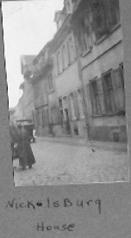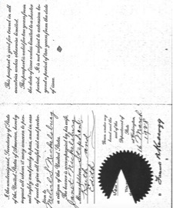

Leopold’s House and Family Passport

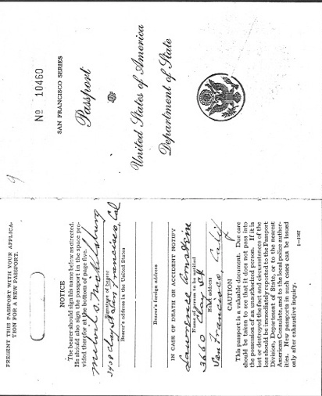

This is probably in Worms. I could identify my Dad, Melvil and Leopold in the picture but not the other two.



With Melvil doing poorly and no hope in Germany they booked a ship home. Disappointing as the trip to Germany and Austria was, it was not a total loss. Melvil learned something far more important in 1928. In his travels he came to understand that the Nazis really meant what they said and were they to come to power, they would move forward with a program of getting rid of the Jews in Germany, one way or another. Even though it was not the “final solution” it was to become, after all Germany had expelled Jews in the past, it was clear to Melvil that the Nazis meant to do it. The only saving grace was that in 1928 it did not seem likely that the Weimar Republic would fall to the Nazis. They only received about 3% of the vote in national elections that year.

In 1933 Melvil’s condition was bad enough that without help he could not get around. In addition to the hired help, my father was able to get a drivers license (he was 14) and he then drove his Dad most places. It seems that if they were not already very close, they certainly became so during this period.

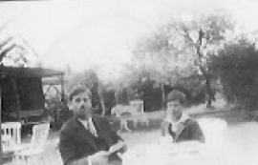

My Dad and Melvil

1933 was also the year that Hitler came to power in Germany. In 1933, 1934 or possibly a late as 1935 (I’m just not sure when this happened) Melvil spoke at a number of Jewish gatherings in San Francisco and told of his travels in Germany. He tried to make the case that the San Francisco Jewish community had an obligation to help the German Jews because Hitler really was going to, at a minimum, expel all Jews from Germany, but as well murdering Jews might be part of the policy.

Melvil was roundly criticized. The general feeling was that there was nothing new in what Hitler was saying, it was just for internal consumption by his base, there would be a few sacrificial Jews but it would blow over, and then things would return to normal. After all, so the argument went, Germany was the center of the civilized world and Jews were an important part of it. Cousin John Rothman in a book he wrote about the Brandenstein family documents this as an ongoing controversy in the San Francisco Jewish community of the time both between and within families.

Melvil told them they were wrong. He was told that he needed to keep his mouth shut because by campaigning for the San Francisco Jewish Community to help the German Jewish Community he was just playing into the hands of those who claimed there was a world Jewish conspiracy. I am quite sure this was not a universal opinion, but Janet confirmed that this was how Melvil viewed it. My mother, unbeknownst to her, confirmed this as well though I did not know it at the time.

As a consequence Melvil distanced himself from the community of his childhood. Melvil was this guy that everyone liked and it hurt my father, who was at his side as son and driver, deeply. But apparently my Grandfather was not someone easily deterred.

Melvil contacted Leopold. Leopold was a doctor and well respected in the Worms Jewish Community. He formed an organization *Hebrews for Germany* to show the loyalty of the Worms Jewish population to the German State and he had a leadership role in the group. This was a true moral dilemma for Jews in Germany and elsewhere in Nazi occupied lands. They could help their people in the short run by seeming to align themselves if not collaborate with the Nazis, but they kept the Jewish population more docile than it otherwise might have been. There is, of course, no clear moral answer to the question of what to do.

But Leopold along with Melvil found one. Melvil began to send money to Leopold. Remember my father said Melvil gave his money away – well here it is. Leopold, while putting on a face of loyalty to Germany, bribed the German officials to get papers and passage for as many Jews in Worms as possible.

I had the odd experience of meeting one of the families for lunch in the Berkeley Hills one day. It was odd because these people with thick German accents were incredibly differential to my grandmother. Indeed, they very nearly worshiped her. And when the subject of Melvil came up, well you would have thought they were speaking of the angel Moroni. Well not really Moroni but we needed to lighten this up a bit. I couldn’t figure out this lunch and I wondered about it for a long time. I asked Granny later about it and found out the connection. Melvil was the reason they were alive.

In 1938 Melvil received a letter from Leopold that basically said, it is now time for me to get out. Melvil sent the bribe money. He did not hear anything from Leopold so he sent another letter with bribe money. Still no word of his passage out of Germany came. Melvil, Granny, and my father assumed that Leopold had been arrested by the Gestapo, and if he were still alive he was in the camps.

In 1941 the U.S. entered World War II. In 1942 my father enlisted and was ultimately sent to the Pacific. In 1944 Melvil died. My father returned from the War, tried to pick up the pieces of his life and move on. He remained bitter to the end about how Melvil was treated by the Jewish Community. And neither he nor Granny would say a word about this. It may be difficult to understand from our perspective, but a sense of shame of not being able to do more, particularly with respect to saving Leopold, of anger that others would not help, and the omnipresent guilt of the survivors made this a family skeleton, a dirty little secret that was not going to see the light of day.

Fortunately they were wrong. And all of us that have the blood of Melvil Nickelsburg (and happily had our monetary treasure given away by him) can look back with pride in our heritage. He is an example for all of us, as important today as ever. As for me, now when I look back at the way in which my father and grandmother would say that I reminded them of Melvil, I smile.

Postscript: A few years ago my friend George Nickelsburg uncovered some documents on a trip to Germany. Apparently, Leopold was not arrested by the Gestapo. He died in late 1937 or early 1938 on the streets of Charlottensburg, a wealthy suburb of Berlin where his daughter Hilde Elisabeth lived with her husband. He collapsed on the street, perhaps from a heart attack. His body was transported back to Worms and buried in the New Israelite Cemetery. Hilde Elisabeth and other members of our family would not be so fortunate, and that is the subject of the third essay.

*Essay No. 3*

*Rosalie and Hilda Elisabeth Nickelsburg and Lilli Baer*

I grew up secure in the knowledge that the Nickelsburgs, being susceptible to gold rush fever, as well as the other branches of my family left Europe prior to 1860. So, being the ne’er–do-well’s we were, we escaped being rounded up by the Gestapo. It turns out that was a myth, and my family of my Dad’s generation knew that. There is not much that I know about the three blood and surnamed relatives of mine murdered by the Nazis in the Concentration Camps, but to do their memory justice, I am putting it down for future generations as best I can.

*Hilda Elisabeth Nickelsburg*

What I know about Hilde comes from a variety of sources, none of which are too revealing except for the journal of her sister in law. Hilda was born September 1, 1901 in Worms, Germany to Dr. Leopold Nickelsburg, a prominent physician and leader in the Worms Jewish community. Leopold’s Grandfather Samuel was a brother to Melvil’s grandfather Marcus. Hilde is therefore a third cousin of my father. She married Dr. Fritz Freund from Darmstadt, Germany on December 24, 1936 at the age of 35. Fritz was in the artillery on the Western Front in World War I and was a war hero. He was awarded the Iron Cross but by the time it was approved, anti-Semitism precluded the actual ceremony awarding it to him.

It appears that they lived in Berlin in Charlottenburg, an affluent neighborhood, for the next few years. They were among the last Jews deported by the Nazis from Berlin. They arrived in Theresienstadt Concentration Camp on February 2, 1943. On 18 May 1944 they were sent to Auschwitz where they were both murdered.

The following is a translation of the journal of Hildegard Freund Shelton, sister to Fritz and sister-in-law to Hilda Nickelsburg. Hildegard was a free spirit. She left Germany early on and went to the British Protectorate of Palestine. After the war she married a British soldier and moved to London. While she was still living I tried to contact her but she would not receive my inquiries.

By chance in May of 2006 I received an envelope from one Elisabeth Krimmel of Darmstat, Germany. She apologized profusely for invading my privacy on such a personal subject, but she was engaged in her PhD research on a famous art critic Dr. Karl Freund and had come across the journal of his niece. She thought I should have a copy of it. This is the excerpt that pertains to Hilde Nickelsburg but it also contains some personal observations on what life was like in the last few years of her life in Berlin.

1937: *Fr.* (Fritz) *+ Hilde were in Worms for the funeral of H.’s father who liked me a lot more than his own daughter whose mother had committed suicide when H. was 18 years old.* (she is describing why after being assaulted in Berlin Fritz who apparently adored her was not there at the time)

*The relationship with Hilde, our sister-in-law was rather difficult. Fritz loved us too much + H. was his slave. We were not good to her either! My sister went eventually to Frankfurt + F. arranged a pleasant little room for me above their flat under the roof I could reach with a ladder from the 5th floor. Later I went to Frankfurt too staying at Tante Hed’s + left over a row with here some time later. It was, at the time, still possible to go out in Berlin for entertainments-we went to the Staatsoper one evening. I went to the “Fermina “ Palace. I had met a Brazilian Student at a party who took me out all over the place. … F. pointed out the J.* (Jewish) *prostitutes on Kurfurststen Damm. They had lost their jobs with the advent of the Nazis + had no other choice to survive. F. just gave them money. Sometimes one saw very “objectionable types of J’s, + that were always unhappy encounters. One felt ashamed, though most of them were unrecognizable as J’s. My hairdresser asked me to act as a model for him – I declined. Things were not really terrible – yet – but one felt all the same as “odd man out” which became severe + unbearable after the “Kristall Nacht” in Nov. 1938 when fortunately we were already back in Palestine. Whereas Fritz and Hilde must have led a hell of a life. We found that they had made contact with Canadian (unrecognizable) Brazilian people for some exchange, but in the end, permission for such a transfer was not allowed. So they got stuck in B. a more + more harrowing thought—*

*Near the end of 1937 I was required to present myself at the Gestapo Headquarters at Alexander Platz. It was a shock! Fritz took me there – waited for me. He guessed that through correspondence the Authorities became aware that my stay in Germany was “illegal” – I was ushered through a barrier into one of the rooms on a long corridor whose glass doors were painted black. There I was interviewed by a simple official who asked personal/financial questions; the answers he typed on an old machine. He asked me even to spell words for him. There was a J. woman in tears in the room,+ a boy of about 16, very distraught. It seemed each was of Polish origin + about to be thrown out of B. The Official then took the typed sheet into an adjoining room. After a little while I had to go to this same room where a Prussian looking Gestapo man sat behind a writing desk. I said “Good morning” – no answer. Again I was questioned, especially why I had come back from Palestine since I had already emigrated. When I mentioned further schooling he said I could go to a “Schulingslager” (Schooling Camp i.e. a Concentration Camp) of theirs – or immediately return to Palestine*…(it took three months for the Germans to complete the paper work for her to leave)

*Beloved happy about signs of life. Apparently both sides post losses. We live and try to bear a future not understandable. Getting Massive Red Cross Month letters describing your life circumstances. Kiss intimately future wunsche Eucherbrien, goodbye, hope response*  The translation (Elisabeth Krimmel writing) is poor at best, but the letter has signatures which is nice.

April 1938: Hildegard left Germany for Palestine. She joined the British Middle East Force during the war and was sent to Cairo where she met Francis Shelton. They were married for 51 years. She filed inquiries about her brother and sister in law, but this journal is the only record of here time in Nazi Germany or cousin Hilde that I have seen.

Below are three documents, one from Yad Vashem, one a response to an inquiry after the War by H. Shelton, and a letter from Hilde, Fritz on December 15, 1941 to Hildegard.

*Rosalie Nickelsburg and Lilli Baer*

Rosalie was born in 1869, the sister of Leopold and daughter of Sigmund. I have learned a bit about Rosalie from her great grandchildren Stacey Oldweiler and Kim Baer. Rosalie married Max Baer and lived in Mannheim. She had a son Ernst and a daughter Lilli born in 1893.

Lilli married Rudolf Langwell and had a daughter Charlotte. Lilli, Rudolf, Charlotte and Lilli’s step-son John lived in Berlin. During the war she was sent to Prague (Theriesenstadt) and then in 1942 to Majdanek death camp in Poland to be murdered. Roselie was also sent to Theresienstadt Concentration Camp. There she was taken care of by John and while in the camp she died. Rudolf’s murder was apparently in transit to the death camps. Charlotte apparently survived the war and immigrated to the United States in 1947. She did not have any children that we know of. John survived and moved to New Jersey where he gave oral testimony (found at USC Shoah project) and the Yad Vashem documents at the end of this essay.

Ernst married Erna and owned a cigar factory. Later he and Erna divorced. Erna married a German and hid out during the war. About 1936 or 1937 Ernst left Germany for England with his two sons Martin and Steve. They went on from there to Amsterdam and then to Chicago and Los Angeles. Upon arriving in Los Angeles he began work as a yarn salesman. Later he took up real estate as a profession. Martin had 2 children and Steve 6, all living in the United States.

It is quite possible that Ernst was able to obtain exit papers on his own and not through Leopold and Melvil, but given that they all knew each other, it is also possible that there is a connection. This we will never know. After arriving in the US Ernst did not have any contact with the Nickelsburg’s in San Francisco that we know of. He must have known of their existence and must have met my father and grandfather during the six months they spent in Germany in 1927 and 1928. However, the pain of leaving loved ones behind may have caused him to want to start a new life and leave the old one far, far behind. It was only by chance that I learned of the survival of him, his children and his grandchildren.

Ernst Baer

